**Amazon CloudFront:** Amazon CloudFront is a content delivery network (CDN) that caches content around the world for lower latency access. AWS Global Accelerator enables access to your application by leveraging the same Edge Locations as CloudFront and routing connections across the AWS global network.

**AWS Direct Connect:** This service provides private connections from data centers to AWS. It is not useful for distributed users as they will not be able to take advantage of it.

**AWS Transit Gateway:** This service is used for optimizing the network topology of interconnected VPCs and on-premises networks.

**AWS Snowcone:** This is used as an edge device for transferring data.

**Predictive Scaling** uses daily and weekly trends to determine when to scale.

**Step Scaling** will launch resources in response to demand.

**Scheduled** scaling helps you to set up your own scaling schedule according to predictable load changes.

**AWS Partner Solutions** are built by Amazon Web Services (AWS) solutions architects and partners to help you deploy popular technologies on AWS, based on AWS best practices for security and high availability.

**AWS CloudFormation** is used to deploy infrastructure from templates.

**AWS Artifacts** provides on-demand access to AWS security and compliance reports.

**AWS Config** is a service used for compliance relating the configuration of AWS resources.

**AWS Macie** is a fully managed data security and data privacy service that uses machine learning and pattern matching to discover and protect your sensitive data in AWS.

**Amazon GuardDuty** is a threat detection service that continuously monitors for malicious activity and unauthorized behavior to protect your AWS accounts, workloads, and data stored.

The **AWS Policy Generator** is a tool that enables you to create policies that control access to Amazon Web Services (AWS) products and resources.

**Amazon Detective** automatically processes terabytes of event data records about IP traffic, AWS management operations, and malicious or unauthorized activity.

**AWS Step Functions** allow developers to coordinate multiple AWS services into serverless workflows. It provides a visual console to visualize the steps in the workflow, helping to build and update applications quickly and monitor the status of each step in the process.

**AWS Outposts** is a fully managed service that offers the same AWS infrastructure, AWS services, APIs, and tools to virtually any data center, co-location space, or on-premises facility for a truly consistent hybrid experience.

**Amazon Connect** provides a seamless omnichannel experience through a single unified contact center for voice, chat, and task management.

**AWS Direct Connect** is used for creating a low-latency private connection to an on-premises data centre.

The **AWS Cloud Development Kit (AWS CDK)** is an open-source software development framework to define cloud application resources using familiar programming languages. With AWS CDK you can stick to using programming languages that are familiar to you and have infrastructure deployed using AWS CloudFormation.

**AWS CodeGuru** is used to review code and provide intelligent recommendations for improvement.

**AWS Config** is used for configuration compliance management.

**Elements of S3 bucket policies:**

* **Principal:** The Principal element specifies the user, account, service, or other entity that is allowed or denied access to a resource. The bucket policy below has a Principal element set to * which is a wildcard meaning any user.
* **Actions:** Actions are the permissions that you can specify in a policy.
* **Resources:** Resources are the ARNs of resources you wish to specify permissions for.
* **Conditions:** Conditions define certain conditions to apply when granting permissions such as the source IP address of the caller.

Benefits of using RDS instead of EC2 – Enables automated backups, software patching.

**Elasticity** can resolve the issue of underutilization as you can easily and automatically adjust the resource allocations for your compute resources based on actual utilization.

An **Amazon Virtual Private Cloud (VPC)** can include multiple Availability Zones. Within a VPC you can create subnets in each AZ that is available in the Region and distribute your resources across these subnets for high availability.

**Amazon MSK (Managed Streaming for Kafka** is a fully managed service that facilitates building and running applications built on Apache Kafka without having to manage the underlying infrastructure.

**Amazon SQS** is a message queue service used to decouple the components of a cloud application.

**Amazon Kinesis** is used for real-time streaming data and can technically be used to build a real-time analytics solution, it is not the best option when the requirement specifically mentions leveraging Apache Kafka. Kinesis has its own streaming data solution that is separate from Kafka.

**Amazon Redshift** is a data warehousing service designed to work with business intelligence tools for analytical reporting.

Deploying relational database on Amazon EC2 will enable you to perform database administration.

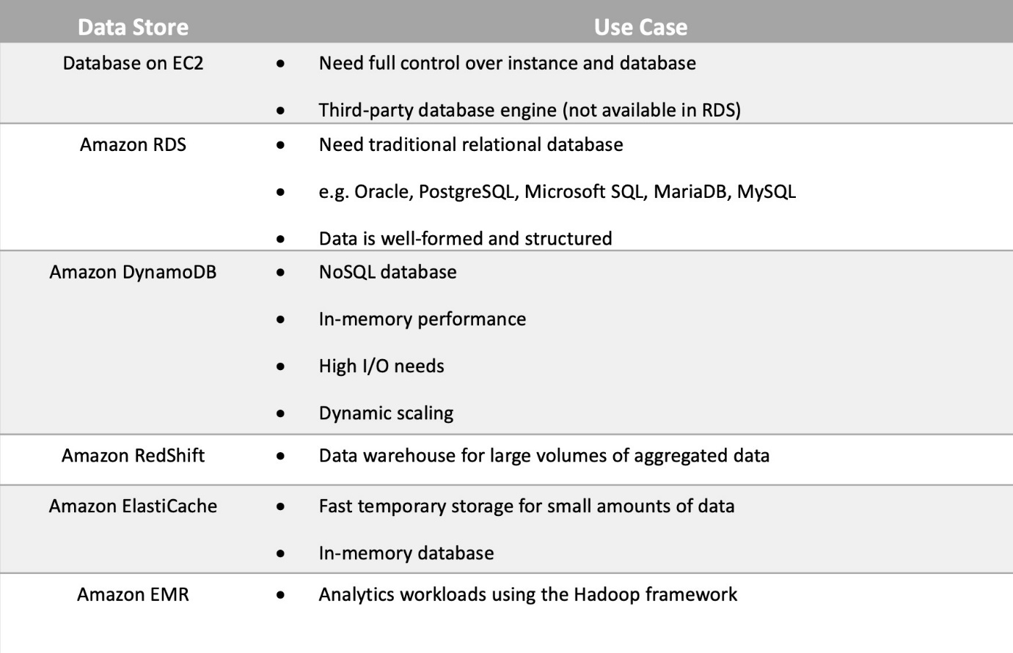

The AWS account name and changing the support plans can only be done using the **root** user access.

An **Amazon Machine Image (AMI)** provides the information required to launch an instance. You must specify an AMI when you launch an instance. You can launch multiple instances from a single AMI when you need multiple instances with the same configuration. You can use different AMIs to launch instances when you need instances with different configurations.

**EBS** is block-based storage for EC2.

**AWS Systems Manager** gives you visibility and control of your infrastructure on AWS**.**

**Amazon AppStream 2.0** is a fully managed non-persistent application and desktop streaming service.

**Amazon Aurora** is a relational database that is compatible with MySQL and PostgreSQL database engines.

**Amazon Athena** is used for querying data in Amazon S3 using SQL.

**AWS DocumentDB** is a NoSQL database that supports document data structures.

**AWS Data Exchange** is the service which allows customers to find, subscribe to, and use third-party data in the cloud.

**AWS Glue** is a fully managed extract, transform, and load (ETL) service that makes it easy to prepare and load data for analytics.

**AWS Data Pipeline** is designed to facilitate the processing and transfer of data between different AWS services and on-premises data sources.

**AWS Artifact** allows you to gain access to AWS security and compliance documents.

A **convertible reserved instance** enables you to *exchange* one or more Convertible Reserved Instances for another Convertible Reserved Instance with a different configuration, including instance family, operating system, and tenancy.

With **Standard Reserved Instances** you cannot change the instance type but you can change the instance size.

**Regional Reserved Instances** apply to instance usage within any AZ in a specified Region.

**Zonal Reserved Instances** help you to apply to instance usage within a specific AZ within an AWS Region.

A microservices architecture will help ensure that each component of the application can scale independently and be updated independently. **Loose coupling** further assists as it places reduces the dependencies between systems and ensures that messages and data being passed between application components can be reliably and durably stored.

**AWS Identity and Access Management (IAM) access keys** are used for making programmatic calls to AWS from AWS APIs.

**AWS Batch** is a compute service